35.13: Use the information given about the bright fringe to find the distance d between the two slits: 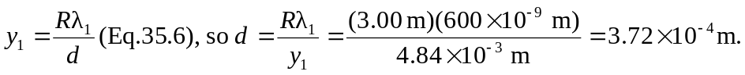
(R is much greater than d, so Eq.35.6 is valid.)
The dark fringes are located by The first order dark fringe is located by sin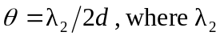 is the wavelength we are seeking.
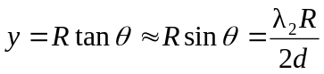
We want 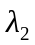such that 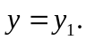 This gives 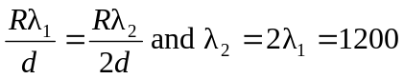nm.

